|  |
| --- |
| SPORKAPPS |
| Hex Runner |
|  |
| Version #1  All work Copyright © 2015 by SporkApps.  All rights reserved. |
| **Justin Caguiat** |
|  |



|  |
| --- |
| March 19th 2015 |

Table of Contents

Version History 3

Game Overview 4

Controls 4

Character 5

Enemies 5

Scoring 5

Bonuses 5

# Version History

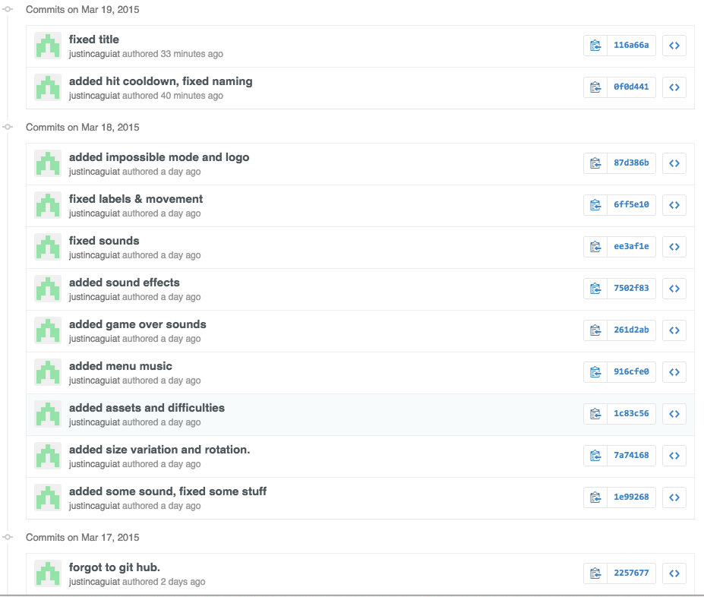

# Game Overview

Hex runner is a side scroller where you play as a Hexagon. Using your mouse, the goal of the game is to avoid the evil circles of various sizes from hitting you. Try and get a highscore and survive as long as you can.

# Controls

Control the hexagon using the mouse. You can move wherever you like on the level.

1. InterfaceSketch

*(What does the game interface look like? Provide a screen shot or sketch)*

1. MenuandScreenDescriptions



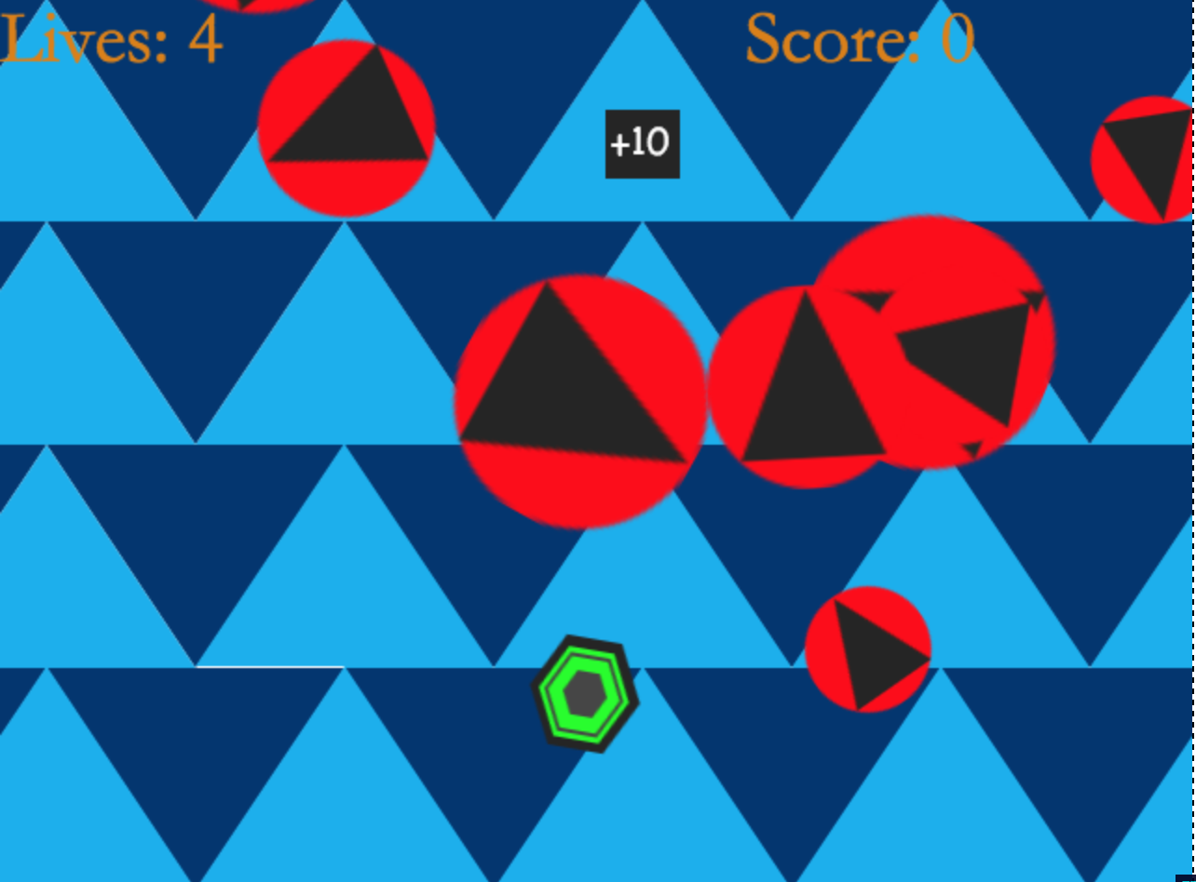

# Character

Macintosh HD:Users:Justin:Documents:Semester6:COMP397-WebGameProg:Assets:Images:SideScroller:hexagon.png

This hexagon is you. The hexagon moves quickly and is only as agile as its controller!

# Enemies

Macintosh HD:Users:Justin:Documents:Semester6:COMP397-WebGameProg:Assets:Images:SideScroller:enemy1.png

These are the bad guys(hazards) avoid them. They are a race of circles who ware triangles as hats.

# Scoring

Pick up these ->Macintosh HD:Users:Justin:Documents:Semester6:COMP397-WebGameProg:Assets:Images:SideScroller:points.png<- to score points. Each one is worth 100 pts… the plus 10 is to trick you!

# Bonuses

Click on the Game logo on the menu screen for a secret Impossible mode!!

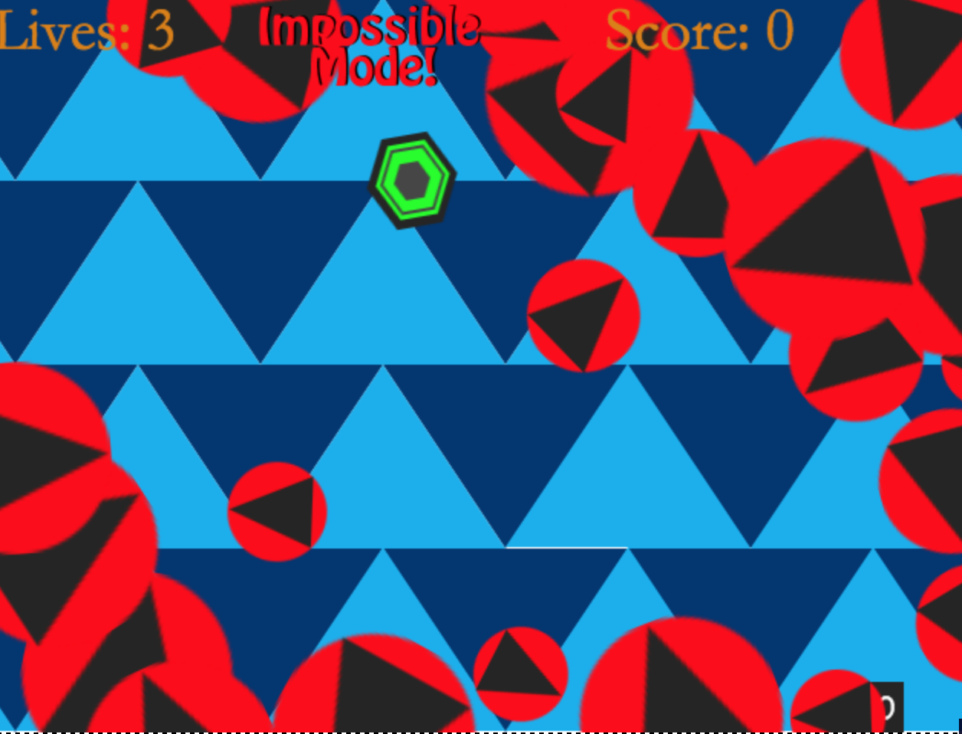

1. SoundIndex

Electronic Super Joy - Endurance.mp3

Electronic Super Joy - RPM.mp3

Gameover.mp3

Horn.mp3

Pew.mp3

1. Art **/** MultimediaIndex



****Macintosh HD:Users:Justin:Documents:Semester6:COMP397-WebGameProg:Assets:Images:SideScroller:enemy1.png***Macintosh HD:Users:Justin:Documents:Semester6:COMP397-WebGameProg:Assets:Images:SideScroller:points.pngMacintosh HD:Users:Justin:Documents:Semester6:COMP397-WebGameProg:Assets:Images:SideScroller:hexagon.png*